**VUI Design plan**

1. **Real-time check popup**
2. **Notification sound while playing audio**

## 

## **What is the Voice User Interface Designer’s job?**

**There is not much difference between VUI design and “traditional” web design. However, there are 3 main aspects VUI designers should focus on:**

* **Conduct** [**user research**](https://www.mockplus.com/blog/post/user-experience-researcher) **to understand who and where (environment) the user is. Designers should also understand the entire communication process between the system and the terminal device from beginning to end;**

**User needs and insights**

1. Interview discussion guide with more open-ended questions
2. Recruit 3-5 different levels voice assistant product users

**Voice Interaction Design**

References

<https://developer.amazon.com/docs/alexa-design/get-started.html>

<http://www.sharethefacts.org/>

<https://reporterslab.org/fact-checking-comes-amazon-echo/>

<https://medium.muz.li/voice-user-interfaces-vui-the-ultimate-designers-guide-8756cb2578a1>

<https://www.justinmind.com/blog/voice-user-experience-design-and-prototyping-for-mere-mortals/>

User flow design key point

Initial Prompt: Welcome to Alexa Skills. What can I help you with?

Error: Sorry – I didn’t understand. You can tell me things like…

Condition:

Order Status -> OrderStatusPrompt

**Error Strategies**

When it comes to designing error strategies, one powerful way is by starting with general to specific. Let’s have a look at this:

System: What’s your date of birth?

Caller: Uh…

System: Just tell me your date of birth using 2 digits for the month, 2 digits for the day, and 4 for the year.

**Usability Testing**

1. User Recruiting
   1. Use participants with different levels of experience using voice-controlled assistants.
2. User Testing
   1. Setting up
      1. Introduce the testing to users
         1. Avoid accidental wake-ups by mute the device in the debrief interview
      2. Introduce the device to users
         1. Turn on the device
         2. What it is?
         3. What does it answer to?
         4. How it can be used?
      3. Consider providing users with a secondary device such as a mobile phone in the session.
         1. So, to minimize the negative impact on the session, even if you are testing post-onboarding experience, consider providing users with a smartphone so they can refer to it for basic language.
      4. Recording Permission
   2. Testing
      1. Guidelines
         1. Allow users to have time in the session to use it as they would naturally
         2. Test at all stages of development.
      2. Activities
         1. Run one or two Pilot Testing before the real testing
   3. Wrap-up
      1. Post-task questionnaire with a debriefing interview
3. Results collection
4. Results analysis

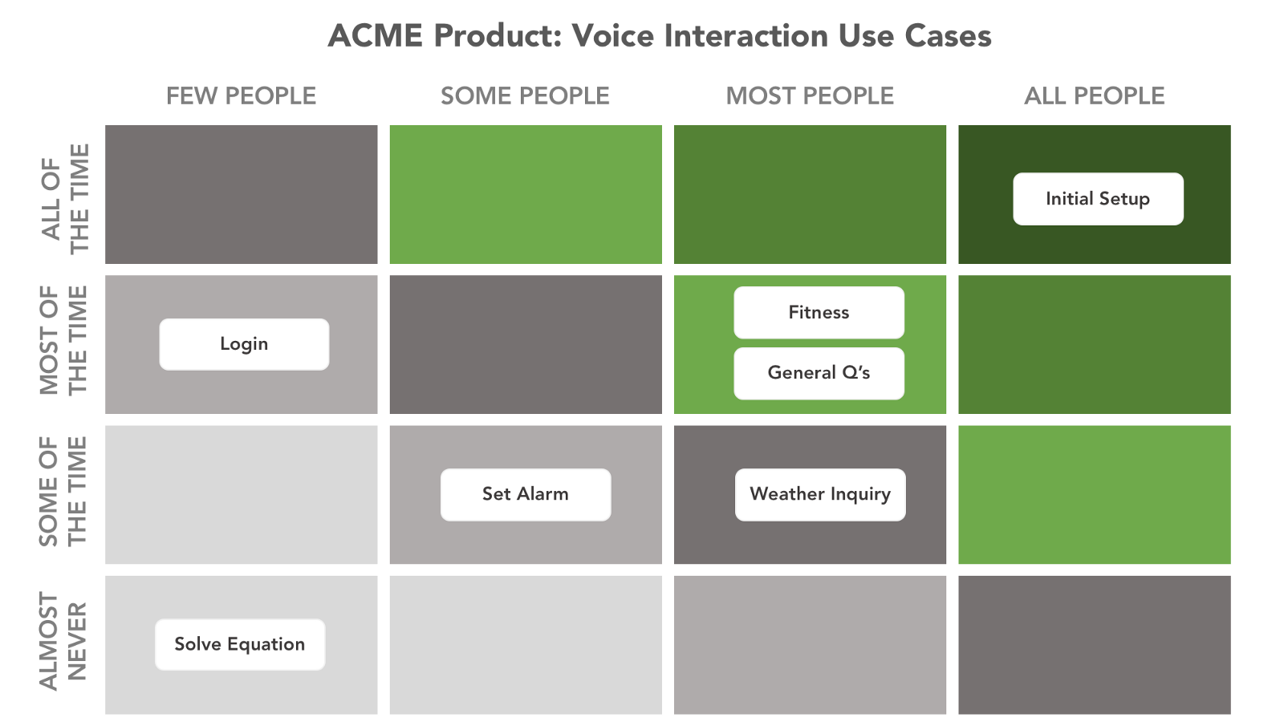

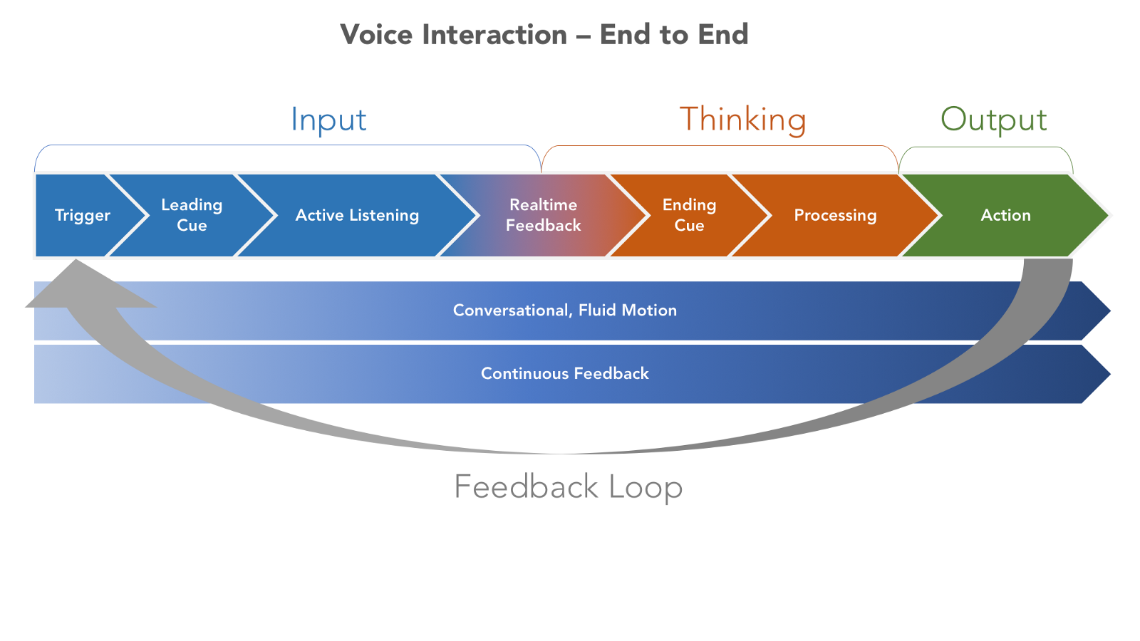

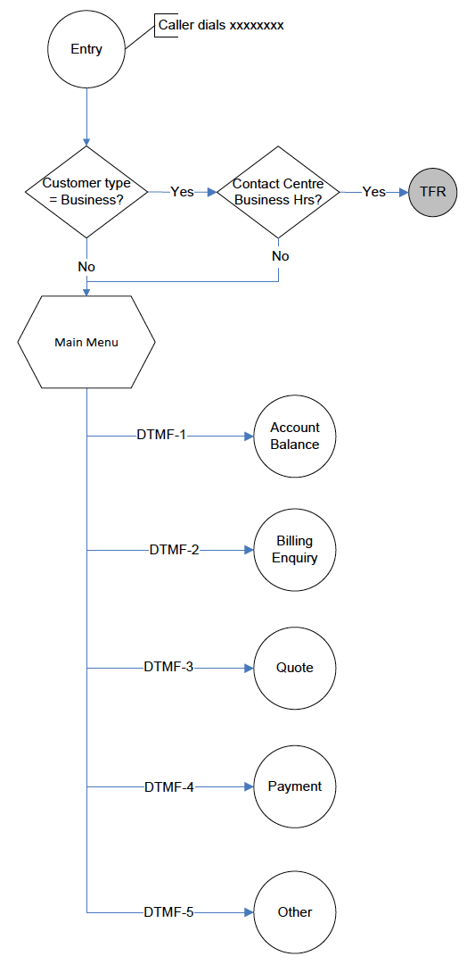

References

1. <https://dotcms.com/blog/post/how-to-build-an-alexa-skill-that-your-audience-will-love>
2. <https://www.simpleusability.com/inspiration/2018/01/5-important-things-usability-testing-of-voice-interaction-using-voice-controlled-assistants/>
3. <https://medium.com/@galeyang/3-usability-testing-mistakes-to-avoid-in-the-age-of-voice-assistants-de7e51d478fd>
4. <https://www.nngroup.com/articles/pilot-testing/>